A000-Afr-Benin-Bronze-Portraait Bust of a Youthful *Oba-*Early 20th c

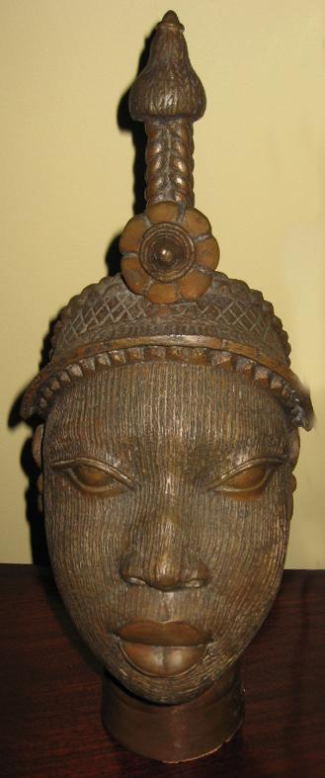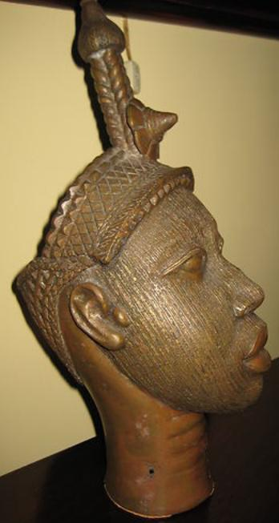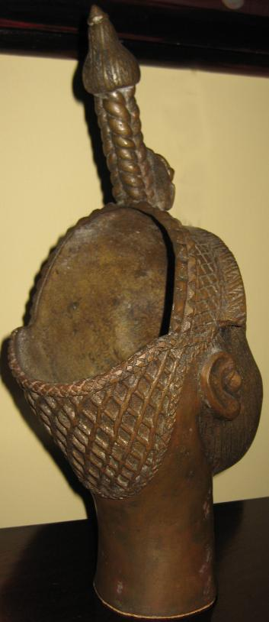

Benin, *Oba* bronze portrait bust, 16 in. tall, 6 in. wide.

This bronze portrait bust of a youthful *Oba* or hereditary leader of Yoruba-speaking Benin can also be identified with *Olokun*, the female deity of the sea who could assume a male identity. The crown with its diamond-shaped structure is thought to be composed of a lattice-work of coral beads, obtained in trade from the Portuguese beginning in 1470 from the Mediterranean. Coral was obviously a metaphor for the sea of which *Olokun* was deity. The length-wise scarifications are similar to those on a Benin reliquary jar portraying a crocodile between land and water, a metaphor of the *Oba* since the *Oba* lived between the ordinary world of his people and the divine world of the spirits and the gods of the *orissa* or Yoruba pantheon. Therefore, these scarifications may signify the flowing nature of water of which *Olokun* was the power.

The leaders of the kingdom of Benin in present-day Nigeria trace their origins to a ruling dynasty that began in the fourteenth century. The title of "*Oba*," or king, is passed on to the firstborn son of each successive king of Benin at the time of his death. The first obligation of each new king during this transition of rule is to commemorate his father with a portrait cast in bronze and placed on an altar at the palace. The altar constitutes an important site of palace ritual and is understood to be a means of incorporating the ongoing influence of past kings into the affairs of their descendents.

Though associated with individuals, this highly stylized genre of commemorative portraiture emphasized the trappings and regalia of kingship rather than specific facial features. In the Edo, Court of Benin, 16th-17th century CE world-view, the head is considered the locus of a person's knowledge, authority, success, and family leadership. The burden of providing for his family and seeing them through times of trouble is often described as the leader being "on his head." The *Oba* is often called by his praise name "Great Head," accentuating the head of the living leader as the locus of responsibility over and for the Benin kingdom.

References:

Forman, W. Forman, B. and Dark, P. 1960. Benin art. London: Hamlyn.

Luschan, F. von. 1919. Die Altertümer von Benin. Berlin and Leipzig: De Gruyter.

Lynch, Patricia Ann. 2004. African mythology A to Z. New York : Facts on File.

Read, Charles H. and Dalton, O. M. 1899. Antiquities from the city of Benin and from other parts of west Africa in the British Museum. London: British Museum.